/\*\*\*\*\*\*\*\*\*\*\*\*\*\*\*\*\*\*\*\*\*\*\*\*\*\*\*\*\*\*\*\*\*\*\*\*\*\*\*\*\*\*\*\*\*\*\*\*\*\*\*\*\*\*\*\*\*\*\*\*\*\*\*\*\*\*\*\*\*\*\*\*\*

Full Name   : Nishit Gaurang Shah

Student ID# : 130 176 217

Email       : ngshah3@myseneca.ca

Section     : SYD366 NGG

Autheticity Declaraition :

I declare that I have done all the coding by myself and only copied the

code that my professor provided to complete my workshops and assignments.

\*\*\*\*\*\*\*\*\*\*\*\*\*\*\*\*\*\*\*\*\*\*\*\*\*\*\*\*\*\*\*\*\*\*\*\*\*\*\*\*\*\*\*\*\*\*\*\*\*\*\*\*\*\*\*\*\*\*\*\*\*\*\*\*\*\*\*\*\*\*\*\*\*/

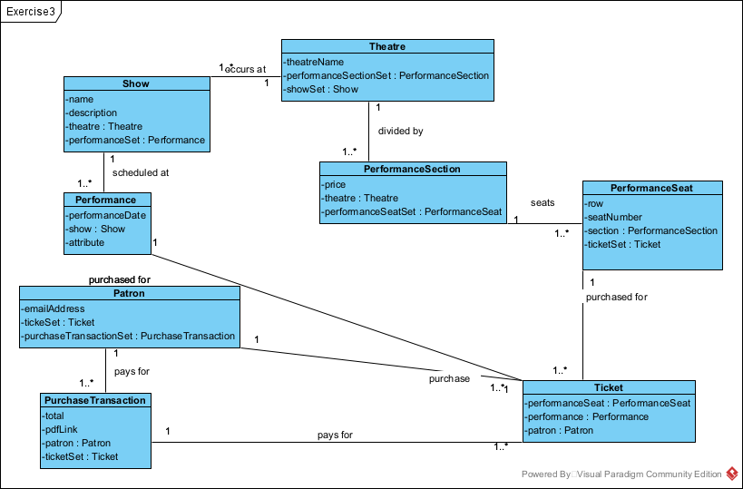

//theatre.h

class Theatre{

    char\* theatreName;

    PerformanceSection\* performanceSectionSet[];

    Show\* showSet[];

}

//performanceSection.h

class PerformanceSection{

    float price;

    Theatre\* theatre;

    PerformanceSeat\* performanceSeatSet[];

}

//performanceSeat.h

class PerformanceSeat{

    int row;

    int seatNumber;

    PerformanceSection\* section;

    Ticket\* ticketSet;

}

//ticket.h

class Ticket{

    PerformanceSeat performanceSeat;

    Performance\* performance;

    Patron\* patron;

}

//purchaseTransaction.h

#include <string>

class PurchaseTransaction{

    int total;

    string pdfLink;

    Patron\* patron;

    Ticket\* ticketSet[];

}

//patron.h

class Patron{

    char\* emailAddress;

    Ticket\* tickeSet; // I did the spelling mistake on purpose since it was in given question.

    PurchaseTransaction\* purchaseTransactionSet[];

}

//performance.h

#include <string>

class Performance{

    string performanceData;

    Show\* show;

    string attribute;

}

//show.h

#include <string>

class Show{

    char\* name;

    string description;

    Theatre\* theatre;

    Performance\* performanceSet[];

}